Individual Assignment Cover Sheet

|  |  |  |  |
| --- | --- | --- | --- |
| Course Code: | **RSM5600HFLEC0101** | Date: | **09-20-2025** |
| Course Title: | **RSM5600H F LEC0101 20259** | **Student Number:** | **1012884425** |
| Instructor Name: | **Marlys Christianson** |  |  |
| Assignment Title: | **Personal Leadership** |  |  |

# 

# 

[Code of Behaviour on Academic Matters](https://governingcouncil.utoronto.ca/secretariat/policies/code-behaviour-academic-matters-july-1-2019).

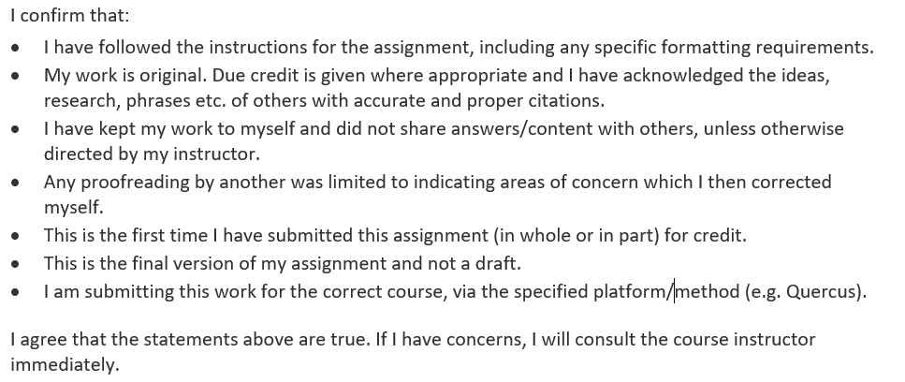

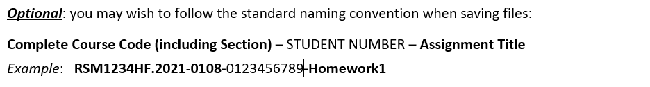

**September 16, 2025 – What Do Leaders Do?**

**Key Learnings:**

1. Leadership vs. Management – John Kotter’s distinction clarified that managers bring stability and order, while leaders drive change and vision
2. Transitioning to Leadership – In “Becoming the Boss,” I realized how many first-time leaders struggle not because of technical gaps, but because of mindset shifts — from “doer” to “enabler” .
3. The Erik Peterson cases highlighted that leadership failure often comes from weak alignment upward and laterally, not from individual effort. Peterson’s lack of managing up and boundary building was fatal

**Personal Reflection (TD Bank connection**):  
At TD, I often straddle the line between managing delivery and influencing strategy. For example, in RPA projects, I sometimes slipped into being “too operational” — ensuring deadlines and compliance — and less on vision-setting. Kotter’s framing helped me see that my role should be to prepare the organization for change (e.g., aligning stakeholders to embrace AI agents beyond bots) rather than just executing tasks.

Similarly, the Peterson case reminded me of moments when I underestimated the importance of managing up. Early in my QE lead role, I focused on building technically flawless test plans, but I neglected to proactively align with senior VPs about risks.

The result: surprises at steering meetings. Now, I consciously use tools like stakeholder maps and “managing up” check-ins — lessons reinforced by this course.

**September 17, 2025 – Leading Teams and Optimizing Team Performance**

**Key Learnings:**

1. **Senior Team Dynamics** – Linda Hill’s note showed that effective teams must balance output, member satisfaction, and learning/adaptability.

Many fail because of rivalries, groupthink, or fragmentation.

1. **Workgroup Model** – Teams aren’t static; they evolve through design, context, and process
2. **Teaming at Disney Animation** – Geibel and Johnson’s restructuring highlighted the value of flattening hierarchy, trust, and psychological safety for innovation

**Personal Reflection (TD Bank connection):**  
These insights hit home because in TD’s Digitization & Automation group, I lead cross-functional pods (RPA developers, analysts, compliance, offshore vendors). Rivalry and fragmentation often surface — e.g., IT vs. business vs. compliance. Hill’s framework showed me that my responsibility is twofold: manage the team boundary (align external stakeholders like Risk, Operations, and CPB leadership) and manage the team itself (design rituals like retros and daily huddles).

The Disney case resonated deeply. Just as Geibel flattened hierarchies to foster collaboration between artists and engineers, I have seen success when I moved from “command-and-control” to **empowerment and trust**. In one Blue Prism initiative, instead of micromanaging, I created open forums where developers could challenge my assumptions. The result: we discovered a compliance risk earlier than expected, saving rework and credibility with regulators.

**September 18, 2025 – Dysfunctional Team Dynamics**

**Key Learnings:**

1. **Dysfunctional Momentum** – Barton & Sutcliffe showed how teams, like wildfire crews, can persist blindly even when signals suggest stopping or pivoting .
2. **Constructive Conflict** – Eisenhardt et al. argued that “a good fight” (facts-based, issue-focused) helps teams make better decisions
3. **Psychological Safety in Conflict** – The art is separating **the person from the problem**, using humor, multiple options, and shared goals to depersonalize disagreements

**Personal Reflection (TD Bank connection):**  
I recognized dysfunctional momentum in automation rollouts. At times, we kept pushing bots into production even when error rates showed underlying process design issues. We were “too deep in execution mode” to pause. This reading made me realize the importance of **building in structured pauses** — checkpoints where we ask, “Do we pivot or stop?”

Equally, constructive conflict is something I’m learning to value. In TD Wealth data strategy, I initially avoided conflicts, preferring harmony. But harmony without candor led to poor design choices. Now, I consciously encourage **issue-based debate** — e.g., in API testing projects, I invite architects and testers to challenge assumptions openly, reminding them it’s not personal. Humor also helps — I often defuse tense meetings with a playful remark about bots “rebelling.”

**Placeholder for September 19–20**

(You can later add reflections on **Leading Teams in a Changing World**, **Working in Virtual Teams**, and **Leading Learning Organizations**. These will link to your TD virtual collaboration experiences and your aspiration to build a learning organization through AI-driven product innovation.)

**Conclusion**

This course reshaped how I see leadership:

* It is not about control, but about enabling change (Kotter).
* It is not about personal heroics, but about boundary and process management (Hill, Peterson).
* It is not about harmony, but about using conflict and momentum wisely (Eisenhardt, Barton).

At TD Bank, these lessons are already reframing how I lead automation, data, and AI initiatives. As I grow into broader leadership roles, I will use these takeaways to align people, build trust, and avoid the traps of dysfunctional teams.

|  |  |  |  |
| --- | --- | --- | --- |
|  | **Final Page** | |  |
|  |  |  |  |
|  | **Grade:** |  |  |

**Please PDF before posting.**